## CSCE 771: Computer Processing of Natural Languages

## Prof. Biplav Srivastava, Fall 2022

## Quiz 2 / Instructions

* This is a programming quiz. Code has to be submitted in a directory of your GitHub called “Quiz2” with sub-dir for code, data and doc. Code will have your source code, data will have any input or output generated, and doc will have a .pdf of this file (called Quiz2-CSCE771-answers.pdf) along with any answers
* Complete quiz by 9:00 am on Monday, Oct 3, 2022 by sending an email to [biplav.s@sc.edu](mailto:biplav.s@sc.edu) confirming completing the quiz and attaching your Quiz2-CSCE771-answers.pdf.
* Total points = 50 + 20 + 30 = 100
* Obtained =

Student Name: Sourin Dey

**Question 1: Contextual word embedding and TF-IDF**

[5 + 5 + 20 + 10 + 10 = 50 points]

(a) What is the benefit of using a counting based vector representation like TF-IDF over a learning based representation like Word2Vec? [5 points ]

**Ans:** TF-IDF calculates the frequency as well as importance of words while Word2Vec provides vector representation (word embedding) of a word which does not have interpretable representation. Word2Vec also requires further works of dimensionality reduction for its word representation. It is also expensive to train such a model.

(b) What are the advantages of character-based representation like fasttext over word-based representation like Word2Vec? [5 points ]

**Ans:** Character-based representations provide infer meaning of unseen word. For example, if a word prestigious is absent in the corpus, it can still find meaning of it by finding meaning of the word prestige. Word2Vec would not be able to do that. Also, in different languages such as in German language, training Word2Vec is difficult. For example, tennis and tischtennis are similar but word2vec won’t recognize it while there will be overlapping n-grams while using fasttext.

(c) In sample-code/l13-llm-quiz folder in course github, you will find a file called “projs.txt” containing the list of projects in the course. Do the following:

1. Consider each line as a document and represent words in TF-IDF. [20 points ]
2. Identify your project name and identify all projects similar to yours. Use a cosine similarity of 0.9 [10 points ]
3. Identify clusters of projects along the same theme, based on similarity of project names. (Hint: you just have to reuse your code from (ii) above) [10 points ]

**Ans: In Quiz2/code/ Quiz question 1.ipynb**

**Question 2: Semantics**

[8 + 12 = 20 points]

Consider text = “show me flights from Boston to anywhere that has flights to Dallas”

1. Using the online AMR tool at <http://amparser.coli.uni-saarland.de:8080/>, find the AMR structure of the example text. Paste it below.

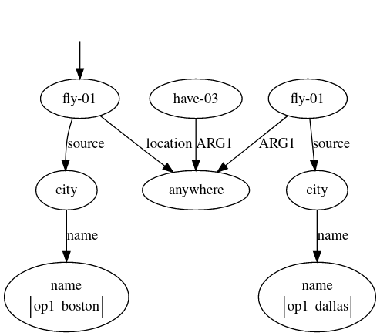

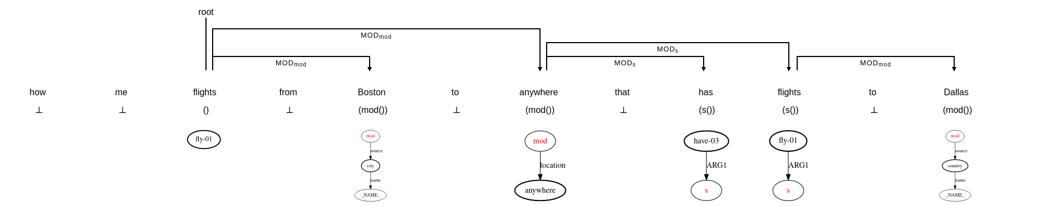

1. The AMR refers to specific variant of **show**, **fly** and **have**. Use pennbank and show the predicate, its arguments and its meaning. Use a propbank visualizer like <https://verbs.colorado.edu/verb-index/index.php>.

Ans: I could not solve this problem.

**Question 3: Word2Vec**

**Ans: In Quiz2/code/ Quiz question 3.ipynb**

[10 + 10 + 10 = 30 points]

1. Take your latest resume (must be more than 1 page). Create a word2vec representation for it using genism and print statistics of embeddings.
2. Visualize the embedding using PCA.

1. Now create and visualize the embedding of the projects listed in the file - sample-code/l13-llm-quiz/projs.txt.

